Order Chris Bray Photography
Embroidered Clothes:

NAME

EMAIL

CONTACT NUMBER

SHIPPING ADDRESS

Please fill in the order form (below), indicating the size and desired quantity of each order item. An invoice will then be sent to you for payment.

Please return order form to sales@chrisbray.net by Sunday 8th December 2013 to take advantage of this offer. All orders will be processed after this date. Thank you for your patience.
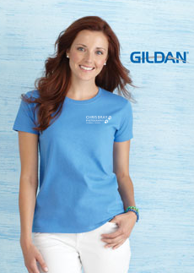
FREE EXPRESS POSTAGE within Australia for orders over $65,
otherwise $10 for express postage.

No refunds or returns.

Men's Sizing Guide
Women's Sizing Guide
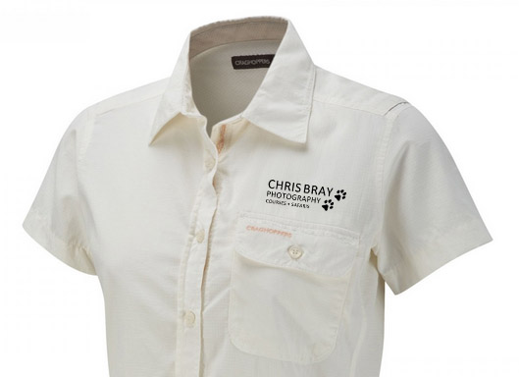
Sizing
Guide
(with Nosilife protection)

ITEM & PRICE | COLOUR | IMAGE | SIZE (Select applicable) | QTY
MENS CRAGHOPPERS SHIRTS (CBP logo embroidered)
NL Long Sleeve Shirt | Parchment | View Image | S, M, L, XL, XXL
$85.00 (RRP $99.95) | Dark Khaki | View Image | S, M, L, XL, XXL
 | Black Pepper | View Image | S, M, L, XL, XXL
 | Dark Bark | View Image | S, M, L, XL, XXL
 | Maya Blue | View Image | S, M, L, XL, XXL
NL Short Sleeve Shirt | Dark Khaki | View Image | S, M, L, XL, XXL
$75.00 (RRP $89.95) | Parchment | View Image | S, M, L, XL, XXL
MENS CRAGHOPPERS TROUSERS (Not embroidered)
NL Convertible Trousers | Pebble | View Image | 30, 32, 34, 36, 38, 40
$89.00 (RRP $119.95) | Dark Bark | View Image | 32, 34
NL Lite Trousers | Black Pepper | View Image | 30, 32, 34, 36, 38
$65.00 (RRP $84.95) | Dark Bark | View Image | 30, 32, 34, 36
 | Pebble | View Image | 30, 32, 38, 40
WOMENS CRAGHOPPERS SHIRTS (CBP logo embroidered)
NL Darla II LS Shirt W | Blue Violet | View Image | 8, 10, 12, 14, 16
$85.00 (RRP $99.95)
NL Darla Long Sleeve Shirt | Sea Salt | View Image | 8, 10, 12, 14, 16, 18
$75.00 (RRP $89.95) | Cocoa | View Image | 8, 10, 12, 14, 16
 | Mushroom | View Image | 8, 10, 12, 14, 16, 18
 | Pale Lilac | View Image | 8, 10, 12, 14, 16, 18, 20
 | Blush Red | View Image | 8, 10, 12, 14, 16, 18
NL Darla Short Sleeve Shirt | Sea Salt | View Image | 8, 10, 12, 14, 16, 18
$65.00 (RRP ($79.95) | Cocoa | View Image | 8, 10, 12, 14, 16
 | Blush Red | View Image | 8, 10, 12, 14, 16
 | Crystal Blue | View Image | 8, 10, 12, 14, 16, 18
WOMENS CRAGHOPPERS TROUSERS (Not embroidered)
NL Convertible Trousers W | Mid Khaki | View Image | 8, 10, 12, 14, 16
$89.00 (RRP $119.95) | Mushroom | View Image | 8, 10, 12, 14, 16
NLife Convertible Trousers | Platinum | View Image | 16, 18
$89.00 (RRP $119.95) | Mushroom | View Image | 16, 18
NLife Trousers | Cocoa | View Image | 8, 10, 12, 14, 16
$75.00 (RRP 99.95)
GILDAN Ultra Cotton T-shirt (CBP logo embroidered)
Gildan Ultra Cotton T-shirt | Navy Blue Men | View Image | S, M, L, XL, 2XL, 3XL, 4XL
$35.00 | Navy Blue Women | View Image | XS, S, M, L, XL, 2XL

